液压冲床

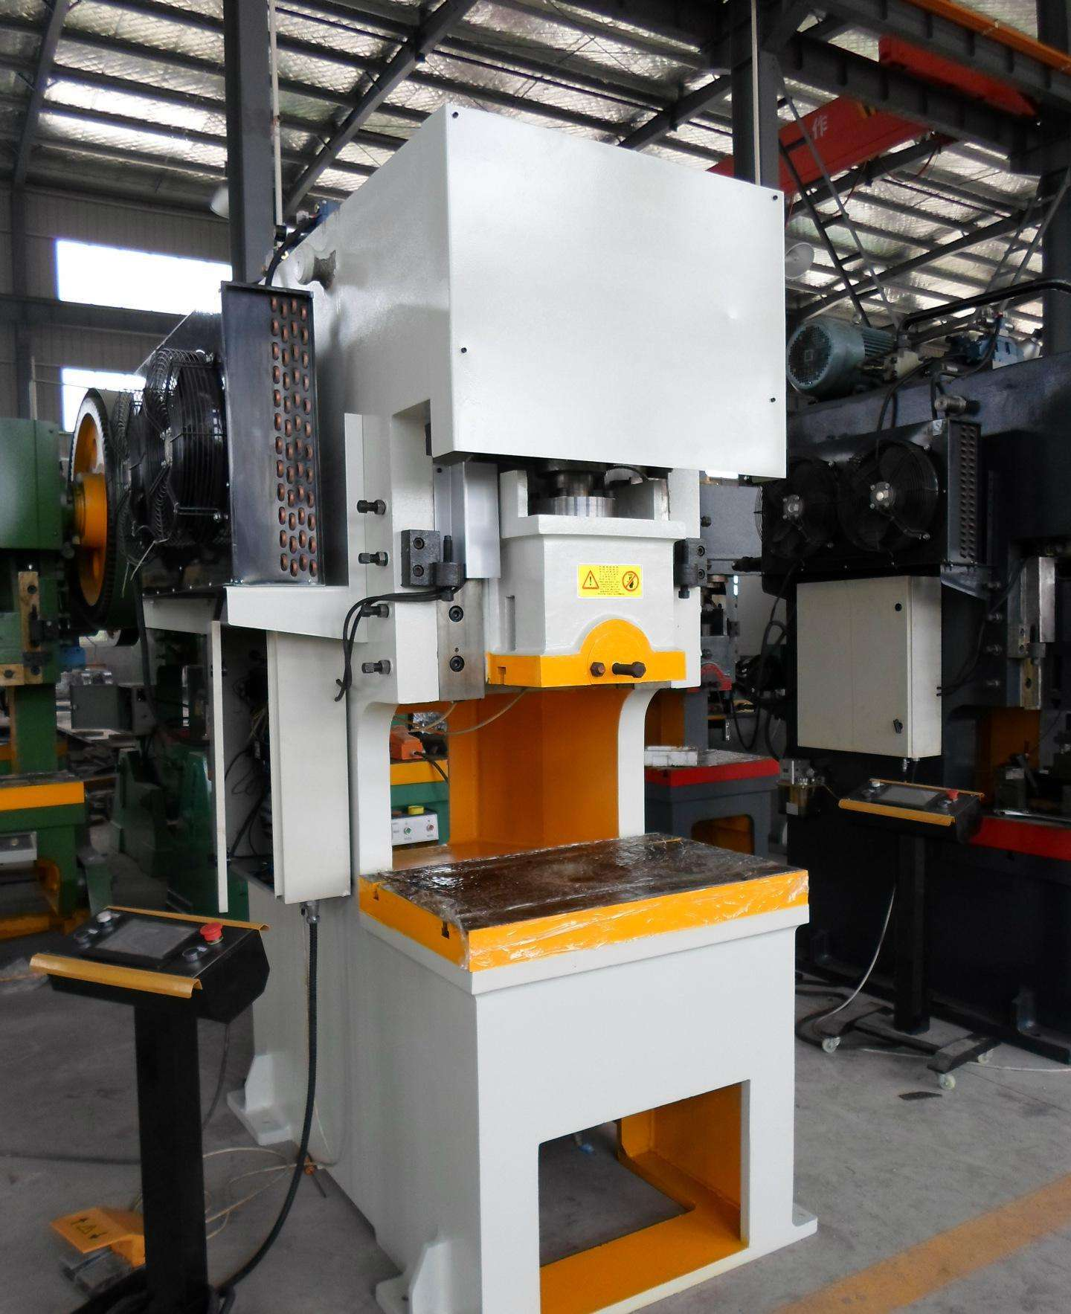
产品性能特点：
本机床主要是承担各种不同厚度板材（0.1mm-20mm）的冲床、折弯、剪切、压装、矫平、挤时间压、拉伸成型等工作。调模精度达到0.1mm，安全、便捷、可靠。软到位冲床技术，提高产品质量及模具使用寿命。智能化控制，确保机器运转及停止的精确性与安全性。具有调整、自动、半自（半自动可分为定程单次和定压单次两种工艺）三种操作方式。滑块的工作压力、空载快速下行和慢速工进的行程范围可根据工艺需要进行调整。机器结构设计合理，便于实现自动化生产，降低成本，提高效率。先进的设计理念，低嗓音，低消耗，节能环保。
选配：
光电安全保掮装置、送料机（空气、机械及CNC各类）、料架、矫平机、机械手、模具照明装置。

Product performance characteristics：
The machine is mainly to undertake a variety of different thickness of the plate - 20 mm (0.1 mm) of the punch, bending, shear, pressure equipment, leveling, extrusion molding time pressure, stretching, etc. The variable precision is 0.1 mm, safe, convenient and reliable. Soft punch technology, improve product quality and the service life of the mold. Intelligent control, to ensure the accuracy and security of the machine and stop. With adjustment, automatic, half since (semi-automatic can be divided into cheng is single and constant pressure single two process) three kinds of operating mode. The slider working pressure, the no-load fast descending and slow work into travel range can be adjusted according to the process. Machine structure design is reasonable, easy to realize automation of production, reduce costs, improve efficiency. Advanced design idea, low voice, low consumption, energy conservation and environmental protection.
optional ：
Photoelectric safety insurance shoulder device, feeder (air, machinery and CNC), rack, leveling machine, manipulator, mold lighting device.

参数名称  Parameter | 单位  Unit | 液压冲床 Hydraulic Punching Press
参数名称  Parameter | 单位  Unit | ZBJ-D-25 | ZBJ-D-40 | ZBJ-D-60 | ZBJ-D-80 | ZBJ-D-100 | ZBJ-D-125 | ZBJ-D-160 | ZBJ-D-200 | ZBJ-D-250
公称力  Nominal pressure | KN | 250 | 400 | 600 | 800 | 1000 | 1250 | 1600 | 2000 | 2500
滑块行程  Stroke of Slide block | mm | 125 | 125 | 125 | 125 | 150 | 150 | 200 | 200 | 250
最快速度  Max speed | mm | 100 | 100 | 100 | 90 | 90 | 90 | 80 | 80 | 70
行程次数  Numbers of stroke | min | 35-80 | 35-80 | 35-80 | 35-80 | 20-80 | 20-80 | 20-80 | 20-80 | 20-80
最大装模高度  Max die height | mm | 300 | 400 | 500 | 500 | 600 | 600 | 700 | 700 | 800
滑块中心至机身距离  Between slide center and frame | mm | 300 | 300 | 350 | 350 | 400 | 400 | 450 | 450 | 450
工作台面尺寸  Work table size | mm | 300*400 | 300*500 | 320*500 | 500*800 | 500*1000 | 650*1100 | 700*1100 | 700*1200 | 800*1200
电机总功率Electric Power | kw | 4 | 4 | 5.5 | 7.5 | 7.5 | 11 | 11 | 15 | 15

